Unit 6:

**Introduction to Data Visualization**

Data visualization is the graphical representation of data and information. By using visual elements like charts, graphs, and maps, data visualization tools provide an accessible way to see and understand trends, outliers, and patterns in data. As we deal with large amounts of data, it's essential to transform raw data into a visual context that is easy to interpret. The goal of data visualization is to communicate complex information clearly and effectively, allowing stakeholders to make informed decisions based on data.

**Key Objectives of Data Visualization:**

1. **Simplify Complex Data:** Turning complex and large datasets into understandable visuals.
2. **Identify Patterns and Trends:** Help in identifying patterns, trends, and correlations that might be missed in text-based data.
3. **Make Data Accessible:** Data visualization allows users to access and understand data more easily than raw numbers.
4. **Effective Communication:** Convey insights in a way that stakeholders can quickly interpret.

**Best Practices in Data Visualization**

To create effective data visualizations, here are some best practices:

1. **Know Your Audience:**
   * Understand whether your audience is technical or non-technical and tailor your visualizations accordingly. For instance, executives may prefer high-level, clean visuals, while analysts might appreciate detailed charts and graphs.
2. **Choose the Right Visualization:**
   * Select the appropriate chart or graph for the type of data and message you want to convey. For example, a line chart is excellent for time-based data, while a bar chart is ideal for comparing categories.
3. **Keep It Simple:**
   * Avoid unnecessary complexity. Visualizations should be easy to interpret and should highlight the most important aspects of the data.
4. **Use Labels and Titles Effectively:**
   * Every chart or graph should have clear labels, titles, and a legend (if necessary) to ensure users understand what the visualization represents.
5. **Maintain Consistency:**
   * Ensure that colors, fonts, and styles are consistent throughout the visualizations to avoid confusion.
6. **Test for Usability:**
   * Before finalizing visualizations, test them with real users to ensure the insights are easily understood and actionable.

## **Data Visualization Techniques?**

Data visualization techniques are **methods and tools** used to represent complex data graphically (charts, graphs, maps, etc.) to uncover insights, identify trends, and communicate findings clearly and efficiently. These techniques bridge the gap between raw data and human understanding.

## **Key Data Visualization Techniques**

### 1. ****Basic Charting Techniques****

These are foundational techniques suitable for most types of data.

#### ✅ **Bar Charts and Column Charts**

* **Use for**: Comparing values across categories.
* **Technique**: Use different colors, order bars meaningfully (e.g., descending), label axes clearly.

#### ✅ **Line Charts**

* **Use for**: Showing trends over time (time series data).
* **Technique**: Add markers, use smooth or stepped lines for clarity, annotate peaks or anomalies.

#### ✅ **Pie and Donut Charts**

* **Use for**: Showing parts of a whole.
* **Technique**: Limit to 5-6 segments, avoid 3D effects, label with percentage for clarity.

### 2. ****Advanced Plotting Techniques****

#### ✅ **Scatter Plots**

* **Use for**: Finding relationships/correlations between two continuous variables.
* **Technique**: Add a trendline, color-code by category, include tooltips for interactivity.

#### ✅ **Bubble Charts**

* **Use for**: Adding a third variable to a scatter plot (bubble size).
* **Technique**: Use transparency to avoid overlap, keep axis scaling appropriate.

#### ✅ **Histograms**

* **Use for**: Visualizing frequency distribution of continuous data.
* **Technique**: Choose bin size carefully, show density curve if needed.

### 3. ****Hierarchical Visualization Techniques****

#### ✅ **Tree Maps**

* **Use for**: Representing hierarchical data with nested rectangles.
* **Technique**: Use color gradients for magnitude, group related items together.

#### ✅ **Sunburst Diagrams**

* **Use for**: Circular version of tree maps.
* **Technique**: Best for showing parent-child relationships in hierarchy.

### 4. ****Multivariate Visualization Techniques****

#### ✅ **Heatmaps**

* **Use for**: Showing values in a matrix using color coding.
* **Technique**: Use color gradients, allow filtering for larger datasets.

#### ✅ **Parallel Coordinates**

* **Use for**: Visualizing multiple variables in a high-dimensional dataset.
* **Technique**: Normalize scales, highlight groups or trends with color.

### 5. ****Geospatial Visualization Techniques****

#### ✅ **Choropleth Maps**

* **Use for**: Showing data by regions or geographic boundaries.
* **Technique**: Use consistent color scales, avoid using too many color shades.

#### ✅ **Symbol Maps**

* **Use for**: Placing circles or icons on maps to represent data.
* **Technique**: Scale symbols proportionally to data, cluster overlapping symbols.

### 6. ****Time-Based Visualization Techniques****

#### ✅ **Time Series Plots**

* **Use for**: Continuous data over time.
* **Technique**: Add moving averages, annotations for important events.

#### ✅ **Gantt Charts**

* **Use for**: Project timelines, task progress.
* **Technique**: Include start/end dates, use color to indicate status.

### 7. ****Interactive and Animated Techniques****

#### ✅ **Dashboards**

* **Use for**: Real-time data monitoring (KPIs, business metrics).
* **Technique**: Combine multiple charts, enable filtering and drilling down.

#### ✅ **Animated Visualizations**

* **Use for**: Showing changes over time dynamically (e.g., animated bar race).
* **Technique**: Control speed, highlight important transitions.

### 8. ****Text-Based Visualization Techniques****

#### ✅ **Word Clouds**

* **Use for**: Showing frequency of words in text data.
* **Technique**: Eliminate stop words, adjust size by importance.

#### ✅ **Tables with Conditional Formatting**

* **Use for**: Precise numeric data with visual cues (e.g., color scale).
* **Technique**: Use color to highlight high/low values or outliers.

### ****Types of Data Visualization****

**Data Visualization** refers to the graphical representation of information and data. It helps users understand complex data patterns, trends, and insights through visual elements like charts, graphs, and maps. There are various types of data visualizations, each suited to a specific kind of data or analysis purpose.

1. **Comparison Visualizations**  
   Used to compare values across categories.  
   Examples:

* **Bar Charts** and **Column Charts** – Compare categories.
* **Line Charts** – Show trends over time.

1. **Composition Visualizations**  
   Show how a whole is divided into parts.  
   Examples:

* **Pie Charts**, **Donut Charts**, **Stacked Bar Charts**.

1. **Distribution Visualizations**  
   Help understand the spread of data.  
   Examples:

* **Histograms**, **Box Plots**, **Violin Plots**.

1. **Relationship Visualizations**  
   Show connections or correlations between variables.  
   Examples:

* **Scatter Plots**, **Bubble Charts**, **Heatmaps**.

1. **Hierarchical Visualizations**  
   Display data in a tree-like structure.  
   Examples:

* **Tree Maps**, **Sunburst Charts**.

1. **Geospatial Visualizations**  
   Map-based visuals to show data by location.  
   Examples:

* **Choropleth Maps**, **Symbol Maps**.

1. **Time-Series Visualizations**  
   Track data across time.  
   Examples:

* **Time Series Plots**, **Gantt Charts**.

1. **Interactive & Dashboard Visualizations**  
   Used for dynamic exploration and real-time monitoring.  
   Examples:

* **Dashboards**, **Interactive Charts**.

## **Tools Used in Data Visualization**

Data visualization tools are essential for converting raw datasets into meaningful visuals such as graphs, charts, maps, and dashboards. These tools empower users—from analysts to executives—to make data-driven decisions, identify patterns, and communicate insights effectively.

The right tool depends on the complexity of the data, technical expertise, and the intended audience. Below is a detailed overview of the most widely used visualization tools with real-life applications and unique strengths.

### ✅ ****1. Microsoft Excel****

**🔍Description**:  
A fundamental tool for data analysis and visualization, widely used across industries for its simplicity and familiarity.

**✨ Key Features**:

* Variety of charts: bar, pie, line, scatter, etc.
* Pivot tables and pivot charts for multi-dimensional data analysis
* Conditional formatting for quick pattern recognition
* Easy integration with other Microsoft Office tools

**💼 Real-Life Use**:

* Financial analysts use Excel to create budget models, visualize trends, and forecast using built-in charts and formulas.
* Business teams generate weekly sales dashboards with slicers and dynamic filtering.

### ✅ ****2. Tableau****

**🔍Description**:  
An industry-leading, interactive data visualization and business intelligence tool known for its user-friendly drag-and-drop interface.

**✨ Key Features**:

* Connects with hundreds of data sources (SQL, Excel, cloud services)
* Real-time analytics with live and extracted data options
* Highly interactive and shareable dashboards
* Built-in AI and storytelling features

**💼 Real-Life Use**:

* Hospitals use Tableau to monitor emergency room occupancy, track patient recovery statistics, and optimize staff allocation in real-time.
* HR departments visualize attrition rates, hiring pipelines, and diversity data.

### ✅ ****3. Power BI (Microsoft)****

**🔍Description**:  
A comprehensive business analytics tool that integrates well within the Microsoft ecosystem, ideal for enterprises.

**✨ Key Features**:

* Seamless integration with Excel, Azure, and SQL databases
* Real-time dashboards with streaming data inputs
* Natural language querying (Q&A) and AI insights
* Strong support for custom visuals and data modeling

**💼 Real-Life Use**:

* Retail chains use Power BI to monitor real-time sales, analyze customer purchasing behavior, and optimize stock management.
* Logistics companies track delivery KPIs and route efficiency metrics.

### ✅ ****4. Google Data Studio (now Looker Studio)****

**🔍Description**:  
A free, cloud-based dashboarding tool for visualizing Google ecosystem data sources like Google Analytics, Ads, and Sheets.

**✨ Key Features**:

* Pre-built templates for digital marketing, SEO, and sales
* Real-time collaboration and sharing, just like Google Docs
* Easy integration with BigQuery, YouTube, Firebase, and more

**💼 Real-Life Use**:

* Digital marketing agencies create client-facing dashboards to track campaign performance, ad ROI, and website traffic metrics.

### ✅ ****5. Python Visualization Libraries****

**(Matplotlib, Seaborn, Plotly, Bokeh)**  
**🔍Description**:  
Ideal for data scientists and programmers seeking full control over visual output and integration within analytics workflows.

**✨ Key Features**:

* **Matplotlib**: Core plotting library, great for static plots
* **Seaborn**: Built on Matplotlib with elegant, statistical plotting
* **Plotly**: Interactive, web-ready charts
* **Bokeh**: Browser-based interactivity for large datasets

**💼 Real-Life Use**:

* Researchers visualize regression trends, distribution plots, and clustering results during model experimentation.
* Engineers build real-time dashboards with Plotly for monitoring IoT sensor data.

### ✅ ****6. R Visualization Libraries****

**(ggplot2, Shiny, plotly for R)**  
**🔍Description**:  
Widely used in statistical analysis and academia, R libraries offer powerful ways to visualize complex data with a focus on statistical rigor.

**✨ Key Features**:

* **ggplot2**: Grammar of graphics approach, ideal for elegant and layered visuals
* **Shiny**: Create web applications for interactive visualizations
* Rich support for statistical plots like boxplots, QQ plots, and density plots

**💼 Real-Life Use**:

* Epidemiologists use ggplot2 to visualize infection curves, R0 trends, and case distributions.
* Government researchers build Shiny apps for public access to census and climate data.

**Visualizing Big Data?**

**Visualizing Big Data** refers to the process of using graphical and interactive tools to represent large and complex datasets in a visual format such as charts, graphs, maps, dashboards, and plots. The main purpose is to **simplify understanding**, **reveal hidden patterns**, and **support data-driven decision-making** by making massive datasets easier to interpret.

**✅ Key Characteristics of Big Data Visualization**

Big data is often described by the **5Vs**:

* **Volume** – Huge amount of data
* **Velocity** – Speed at which data is generated
* **Variety** – Different formats (text, images, video, logs, etc.)
* **Veracity** – Quality and trustworthiness
* **Value** – Useful insights derived from data

Visualizing big data aims to **turn raw, unstructured data into meaningful visuals** that can answer business questions, monitor trends, and predict future behavior.

**🎯 Purpose of Big Data Visualization**

* Identify trends, outliers, and patterns
* Monitor real-time operations (e.g., stock prices, sensor data)
* Support business intelligence and reporting
* Enhance data storytelling for better communication
* Aid in decision-making by presenting data intuitively

## **Challenges to Big Data Visualization and How to Overcome Them**

Big data brings massive volumes, velocities, and varieties of data, making its visualization not only complex but also computationally intensive. The goal is to extract insights in a meaningful and interpretable form, but several challenges arise in doing so.

Here are **six major challenges** in Big Data Visualization and ways to tackle them:

### ✅ ****1. Volume of Data (Scalability Issue)****

**Challenge**:  
Big data can involve terabytes or even petabytes of information. Visualizing such massive volumes can overwhelm conventional tools, resulting in slow rendering, lag, or even system crashes.

**How to Overcome**:

* Use **aggregation techniques** (e.g., summarizing, grouping) to reduce data complexity.
* Apply **data sampling** to visualize a representative subset.

### ✅ ****2. High Velocity of Data (Real-Time Visualization)****

**Challenge**:  
In domains like finance, social media, or IoT, data is generated in real time. Capturing and visualizing fast-moving data streams in real-time dashboards is difficult.

**How to Overcome**:

* Implement **real-time data processing frameworks** like Apache Kafka or Apache Flink.
* Apply **threshold-based alerts** instead of continuous live visual updates for critical monitoring.

### ✅ ****3. Data Variety (Structured, Semi-Structured, Unstructured)****

**Challenge**:  
Big data comes in different formats: structured (databases), semi-structured (JSON, XML), and unstructured (text, video, audio). Visualizing such heterogeneous data sources is a complex task.

**How to Overcome**:

* Use **ETL tools** (Extract, Transform, Load) to convert different formats into structured forms.
* Leverage tools like **Talend**, **Apache NiFi**, or **Microsoft Azure Data Factory** for data integration.

### ✅ ****4. Poor Data Quality and Noise****

**Challenge**:  
Big data often includes **incomplete, duplicate, inconsistent, or noisy data**, which can mislead visualization outputs and interpretations.

**How to Overcome**:

* Perform **data cleaning** using tools like OpenRefine or Python libraries (Pandas, NumPy).
* Implement **data validation rules and anomaly detection** mechanisms.
* Use **preprocessing techniques** like normalization, deduplication, and outlier detection.

### ✅ ****5. Visual Clutter and Cognitive Overload****

**Challenge**:  
Too much information in a single chart or dashboard can lead to confusion and misinterpretation. This is especially true when visualizing multi-dimensional data.

**How to Overcome**:

* Use **dimensionality reduction techniques** like PCA or t-SNE before visualization.
* Apply **design principles** like minimalism, white space, and interactive filters.

### ✅ ****6. Tool Limitations and Performance Constraints****

**Challenge**:  
Not all visualization tools are optimized for handling big data. Some tools may struggle with large datasets, leading to performance bottlenecks.

**How to Overcome**:

* Choose big data-friendly tools such as **Tableau with Extracts**, **Apache Superset**, **Google Data Studio**, or **Power BI with cloud integrations**,

**Analytical Techniques in Big Data Visualization**

Big data visualization is not just about making data look good — it involves applying analytical techniques to uncover insights, detect patterns, and support decision-making. These techniques enhance the value of visualization by combining visual elements with data science and statistical methods.

**1. Descriptive Analytics**

* **Purpose:** Understand *what happened* using summary statistics
* **Techniques:** Mean, median, mode, frequency, standard deviation
* **Tools:** Bar charts, line graphs, pie charts, histograms
* **Use Case:** E-commerce companies tracking daily orders and revenue

🔹 **2. Diagnostic Analytics**

* **Purpose:** Discover *why something happened* by finding root causes
* **Techniques:** Drill-down, data mining, correlation analysis
* **Tools:** Scatter plots, heatmaps, matrix charts
* **Use Case:** Analyzing customer churn using complaint trends

🔹 **3. Predictive Analytics**

* **Purpose:** Forecast *what is likely to happen* using models
* **Techniques:** Regression, time series forecasting, classification
* **Tools:** Trend lines, forecast curves, probability charts
* **Use Case:** Retailers forecasting festive season demand

🔹 **4. Prescriptive Analytics**

* **Purpose:** Recommend *what actions to take* for optimal outcomes
* **Techniques:** Decision trees, optimization, scenario analysis
* **Tools:** Decision tree visuals, scenario dashboards
* **Use Case:** Logistics optimizing delivery routes using traffic/weather data

🔹 **5. Cluster Analysis**

* **Purpose:** Group *similar data points* for segmentation
* **Techniques:** K-means, hierarchical clustering
* **Tools:** Cluster maps, bubble charts, 3D scatter plots
* **Use Case:** Marketers identifying customer segments

🔹 **6. Network Analysis**

* **Purpose:** Understand *relationships and interactions* in networks
* **Techniques:** Graph theory, centrality measures
* **Tools:** Node-link diagrams, network graphs
* **Use Case:** Telecoms detecting fraud rings or influencer networks

🔹 **7. Geospatial Analysis**

* **Purpose:** Analyze data *based on location/geography*
* **Techniques:** Spatial clustering, geocoding, spatial statistics
* **Tools:** Choropleth maps, symbol maps, geographic heatmaps
* **Use Case:** Governments tracking COVID-19 spread or vaccination rates.

### ****Hadoop Ecosystem Explanation****

The **Hadoop Ecosystem** refers to a suite of tools and frameworks designed to work together with **Apache Hadoop**, enabling the processing, storage, and analysis of big data across distributed systems. The Hadoop ecosystem includes several components that extend the functionality of the core Hadoop framework. These components can be categorized into the following areas:

1. **Storage**
   * **HDFS (Hadoop Distributed File System):** The primary storage system of Hadoop, HDFS stores large datasets across multiple machines. It is designed to be highly fault-tolerant, distributing data across nodes in the cluster.
2. **Processing**

* **MapReduce**: A programming model for processing large data sets in parallel using "Map" and "Reduce" functions.
* **YARN**: Hadoop’s resource manager that schedules tasks and manages resources across the cluster.

1. **Data Integration and Ingestion**
   * **Sqoop:** A tool used for transferring bulk data between Hadoop and relational databases (e.g., MySQL, Oracle).
   * **Flume:** A distributed data ingestion system that collects, aggregates, and moves large amounts of log data into Hadoop.
2. **Data Storage and Management**

* **HBase**: A NoSQL, column-oriented database on HDFS; supports real-time read/write on big data.
* **Hive**: A data warehouse tool with an SQL-like language (HiveQL) for querying large datasets.
* **Pig**: A platform using Pig Latin for analyzing large data sets with parallel processing.
* **Oozie**: A workflow scheduler for managing and coordinating Hadoop jobs like MapReduce, Pig, and Hive.

1. **Data Processing and Analytics**

* **Mahout**: A scalable machine learning library for classification, clustering, and recommendation systems.
* **Spark**: A fast, in-memory big data engine for processing, supporting streaming, ML, and SQL. Often faster than MapReduce and can run on Hadoop.

1. **Visualization**
   * **Hue:** A web-based user interface for interacting with Hadoop components, enabling users to query data, run MapReduce jobs, and more.

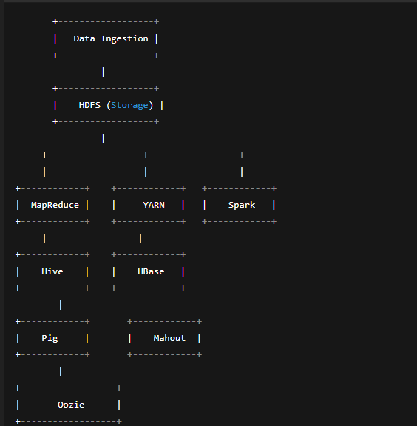

**Five essential Hadoop shell commands:**

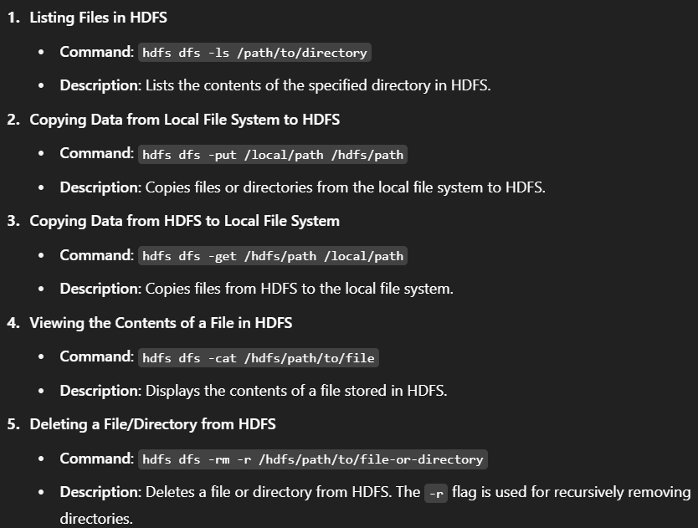

### ****Explain MapReduce with Proper Diagram for Word Count Example****

**MapReduce** is a programming model and a processing technique that allows distributed processing of large datasets on a Hadoop cluster. It works by dividing tasks into smaller sub-tasks that are processed in parallel across different nodes in the cluster. The output of the MapReduce job is an aggregated result.

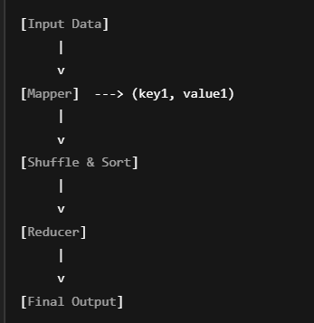

#### **MapReduce Word Count Example:**

In a word count example, the task is to count the occurrences of each word in a large dataset. This task is divided into two main phases:

1. **Map Phase**: The input data is processed by the **Mapper**. The mapper reads the input data (text) and splits it into words. Each word is mapped to a key-value pair, where the key is the word itself and the value is 1 (indicating a single occurrence of the word).
2. **Shuffle and Sort Phase**: The framework automatically groups the key-value pairs by the key (word). It sorts the key-value pairs so that all occurrences of the same word are grouped together.
3. **Reduce Phase**: The **Reducer** receives the grouped key-value pairs and aggregates the values. The reducer sums the occurrences of each word and outputs the final count for each word.

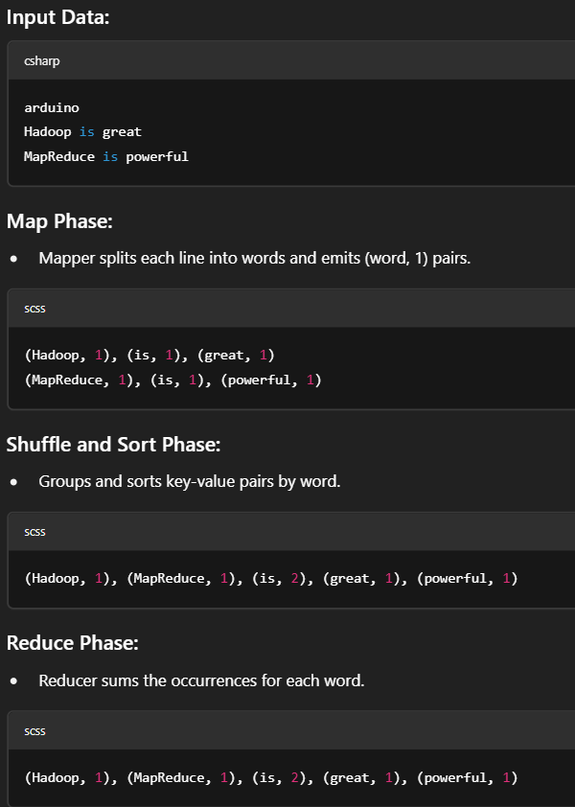

### ****Draw and Explain the Architecture of Hive****

**Hive** is a data warehouse infrastructure built on top of Hadoop. It provides an SQL-like language (HiveQL) for querying and managing large datasets. Hive abstracts the complexity of writing low-level MapReduce programs, making it easier for users familiar with SQL to work with big data.

#### **Hive Architecture Overview**:

1. **Client Interface**:
   * Hive provides multiple interfaces for interacting with data: the **CLI (Command Line Interface)**, **Hive Web Interface**, and **JDBC/ODBC interfaces** for integration with other applications.
   * Users write HiveQL queries (similar to SQL) to interact with the data stored in HDFS.
2. **HiveQL Compiler**:
   * The HiveQL compiler is responsible for parsing the queries, checking syntax, and converting them into an optimized execution plan.
   * It generates a query execution plan, which is then converted into MapReduce jobs.
3. **Execution Engine**:
   * The execution engine takes the query plan from the compiler and executes it by submitting tasks to the Hadoop cluster. The tasks are converted into MapReduce jobs that run on HDFS.
4. **Metastore**:
   * The Metastore is a central repository that stores metadata about the database tables, including schema, partitions, and table properties.
   * It helps in managing the structure of data stored in HDFS and is crucial for the query optimization process.
5. **Hadoop**:
   * Hive runs on top of Hadoop and uses HDFS for storing data. It leverages MapReduce for processing the data, allowing users to work with large datasets efficiently.

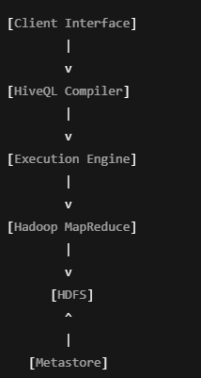

### ****Explain the Architecture of Apache Pig****

**Apache Pig** is a high-level platform for creating MapReduce programs used with Hadoop. It provides a simpler interface than raw MapReduce and uses a language called Pig Latin to express data transformation.

#### **Architecture of Apache Pig**:

1. **Pig Latin Scripts**:
   * Pig programs are written using **Pig Latin**, a language that abstracts the complexities of writing MapReduce code. It provides operators to perform data operations like join, filter, and group.
2. **Pig Compiler**:
   * The Pig compiler takes Pig Latin scripts and converts them into a series of MapReduce jobs. This conversion makes it easy for users to write complex data processing logic without worrying about MapReduce code.
3. **Execution Engine**:
   * The execution engine runs the MapReduce jobs generated by the compiler. It submits tasks to the Hadoop cluster for processing and coordinates the execution.
4. **Hadoop**:
   * Pig runs on top of Hadoop, utilizing HDFS for data storage and MapReduce for parallel processing. Pig scripts generate MapReduce jobs, which are executed on the Hadoop cluster.
5. **Grunt Shell**:
   * The **Grunt Shell** is an interactive shell for running Pig Latin commands. It helps in running commands interactively and viewing results on the fly.

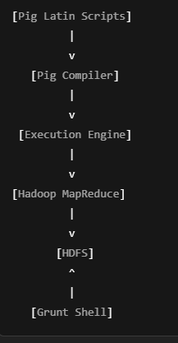

### ****Hive and Hadoop Workflow with Diagram (6 Marks)****

**Overview:**  
Apache Hive is a data warehouse tool that runs on top of Hadoop. It allows users to write SQL-like queries (HiveQL), which are translated into MapReduce jobs for processing large-scale data stored in HDFS (Hadoop Distributed File System).

**Workflow Explanation:**

1. **Client Interface**: User submits a HiveQL query.
2. **HiveQL Compiler**: Parses and compiles the query into a DAG (Directed Acyclic Graph).
3. **Execution Engine**: Converts logical plan to physical plan and coordinates the job execution.
4. **Hadoop MapReduce**: Executes the job using the MapReduce engine.
5. **HDFS**: Reads input data and stores final output.
6. **Metastore**: Stores schema information (tables, columns, partitions, data types).

**Data Visualization using Python: Line Plot, Scatter Plot, Histogram, Density Plot, Box Plot**

Python is widely used for data visualization. Libraries like matplotlib, seaborn, and pandas are extensively used for this purpose. Below are explanations and examples with Python code for **Line Plot**, **Scatter Plot**, **Box Plot**, **Histogram**, and **Density Plot**.

### ****i) Line Plot:****

**Definition:**  
A **line plot** is a graph that displays information using points (markers) connected by straight lines. It is commonly used to visualize trends over time (time-series data).

**Python Code for Line Plot:**

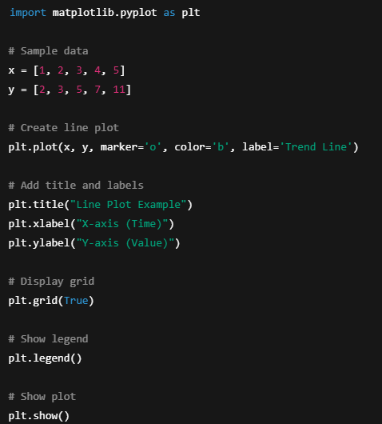

**Explanation:**

* x and y are the data points.
* plt.plot() creates a line plot with markers at each data point.
* Labels and a title are added for clarity.
* The grid is enabled to make trends more visible.

**Usage:**  
Used to track changes over time, such as stock prices, temperature variations, etc.

**ii) Scatter Plot:**

**Definition:**  
A **scatter plot** shows individual data points on a two-dimensional plane. It is useful for identifying relationships or correlations between two variables.

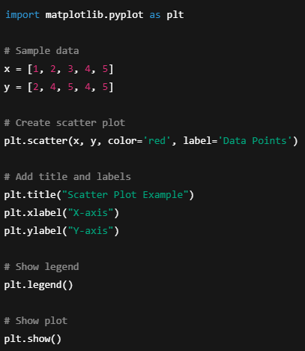

**Explanation:**

* plt.scatter() is used to plot the individual data points.
* This helps to visually identify relationships, like positive or negative correlation.

**Usage:**  
Used in identifying trends, distributions, and correlations, e.g., between height and weight.

**iii) Box Plot:**

**Definition:**  
A **box plot** (or box-and-whisker plot) is used to summarize the distribution of a dataset. It shows the median, quartiles, and outliers.

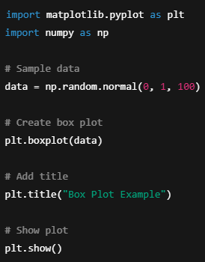 **Explanation:**

* The box represents the interquartile range (IQR), with a line inside the box showing the median.
* The "whiskers" extend to the minimum and maximum values, excluding outliers.
* Outliers are displayed as individual points beyond the whiskers.

**Usage:**  
Used to show the spread and detect outliers in data. For example, analyzing test scores, sales performance, etc.

**iv) Histogram:**

**Definition:**  
A **histogram** is a type of bar chart that represents the frequency distribution of a dataset. It divides the data into bins and displays how many data points fall into each bin.

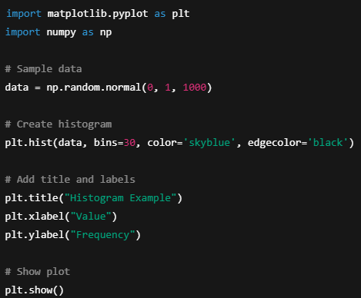 **Explanation:**

* plt.hist() generates the histogram with the given data and specified number of bins.
* It helps visualize the distribution and frequency of data points in different ranges.

**Usage:**  
Commonly used to visualize the distribution of numerical data, such as age distribution or income levels.

**v) Density Plot:**

**Definition:**  
A **density plot** is a smoothed version of a histogram, typically used to visualize the probability density of the data distribution. It’s a continuous plot rather than a discrete bar chart.

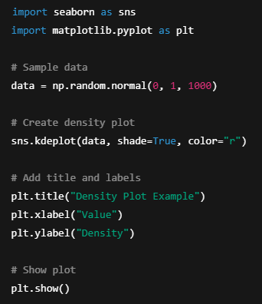 **Explanation:**

* sns.kdeplot() creates a smooth curve representing the estimated probability density function of the data.
* It is often used to understand the distribution of continuous data.

**Usage:**  
Used to visualize the distribution of continuous variables like height, weight, temperature, etc.

**Describe the Data visualization tool “Tableau”. Explain its applications in brief**

**Tableau** is a leading data visualization tool widely used for business intelligence (BI). It allows users to create interactive and shareable dashboards, reports, and visualizations from raw data. Tableau’s intuitive drag-and-drop interface and strong integration capabilities make it a preferred tool for data analysts and decision-makers who need to gain insights from complex data quickly.

**Key Features of Tableau:**

1. **Ease of Use:**
   * User-friendly drag-and-drop interface.
2. **Interactive Visualizations:**
   * Users can create interactive and dynamic visualizations
   * Offers a variety of chart types like bar, line, pie, scatter plots, heatmaps, and more.
3. **Real-Time Data Access:**
   * Tableau can connect to real-time data sources, allowing businesses to visualize and analyze up-to-date information instantly.
4. **Data Connectivity:**
   * Can connect to a variety of data sources, including relational databases (e.g., MySQL, SQL Server), cloud databases (e.g., Google Analytics, Amazon Redshift), and file formats like Excel, CSV, and JSON.
5. **Dashboards and Reports:**
   * Create customizable dashboards that combine multiple visualizations and data sources in a single view.
   * Users can filter data, drill down into specific details, and view trends.
6. **Data Preparation:**
   * Tableau provides tools for data cleaning, transformation, and blending before visualization, ensuring that users work with high-quality data.
7. **Collaboration and Sharing:**
   * Tableau allows users to share reports and dashboards with colleagues or clients via Tableau Server or Tableau Online.
   * Provides options for embedding reports into web pages, emails, and other applications.

**Applications of Tableau:**

1. **Business Intelligence (BI) and Reporting:**
   * Tableau is commonly used for business analytics, helping companies track key performance indicators (KPIs) and analyse sales, marketing, financial, and operational data.
2. **Data Exploration and Analysis:**
   * It helps analysts quickly explore data, identify patterns, correlations, and anomalies, and perform in-depth analysis.
3. **Financial Analytics:**
   * Financial institutions use Tableau to analyze revenue, expenditures, budget allocation, and other financial metrics.
4. **Healthcare Analytics:**
   * Tableau is used in the healthcare industry to monitor patient data, track treatment outcomes, and manage hospital operations.
5. **Supply Chain Management:**
   * Tableau helps optimize supply chain operations by visualizing data on inventory, delivery times, supplier performance, and logistics.
6. **Customer Analytics:**
   * Organizations can analyze customer behavior, preferences, and feedback to improve service and marketing strategies.

### Role of Job Tracker and Task Tracker in Hadoop Architecture

Hadoop's architecture is based on the MapReduce framework, which uses two main components for managing and scheduling tasks: **JobTracker** and **TaskTracker**.

#### **JobTracker:**

* **Role:** The JobTracker is the master daemon responsible for managing the execution of jobs in the Hadoop cluster. It acts as the coordinator and scheduler for MapReduce jobs.
* **Responsibilities:**
  + **Job Scheduling:** It schedules the tasks and assigns them to TaskTrackers based on availability and resource capacity.
  + **Monitoring:** It monitors the progress of tasks and handles the retries in case of failures.
  + **Resource Allocation:** It interacts with the ResourceManager (in YARN) for allocating resources for the job execution.
  + **Job Coordination:** It communicates with the TaskTrackers to assign them tasks and monitors their completion.

#### **TaskTracker:**

* **Role:** TaskTracker is a slave daemon that runs on each node in the Hadoop cluster. It executes the individual tasks (Map or Reduce) assigned by the JobTracker.
* **Responsibilities:**
  + **Task Execution:** It is responsible for executing map and reduce tasks on the node.
  + **Reporting:** After completing tasks, it reports the status and progress back to the JobTracker.
  + **Task Monitoring:** It monitors the task's success or failure and reports any errors to the JobTracker.
  + **Task Distribution:** If the node fails, the TaskTracker helps in rescheduling the tasks on another available node.

**Customization of Plots and Graphical Representations in Data Science**

In Data Science, customizing plots and graphical representations is crucial for effectively communicating insights. Tailored visualizations help highlight important aspects of the data and make the findings more comprehensible. Below are key customizations for various plot types:

**1. Line Plot Customizations**

* **Line Style:** Change the line to solid, dashed, or dotted to represent different data series.
* **Line Width:** Adjust the thickness of the line for better visibility.
* **Color:** Customize the color of the line to differentiate between multiple lines.
* **Markers:** Add markers at data points for emphasis, using different shapes (circles, squares, etc.).
* **Legends and Titles:** Include legends to label different data series, and add titles and axis labels to explain what the plot represents.

**2. Scatter Plot Customizations**

* **Point Color:** Modify the color of the points to indicate different categories or values.
* **Point Size:** Adjust the size of the points to represent additional data features (e.g., frequency or magnitude).
* **Transparency:** Control transparency to avoid overlap in dense datasets.
* **Markers:** Change the shape of points (e.g., circle, square, triangle) for distinction.
* **Gridlines:** Enable gridlines for better readability of the data points.

**3. Bar Plot Customizations**

* **Bar Color:** Set different colors for the bars to distinguish between categories.
* **Bar Width:** Adjust the width of the bars to control spacing between them.
* **Orientation:** Use horizontal bars for better representation of certain data types (especially for long category names).
* **Edge Color:** Highlight the edges of the bars for a clearer structure.
* **Tick Labels:** Customize the tick labels on the x and y axes to improve clarity.

**4. Histogram Customizations**

* **Bin Size:** Control the number of bins to adjust the resolution of the distribution.
* **Bar Color:** Modify the color of the bars to match the theme or highlight specific data characteristics.
* **Transparency:** Adjust transparency (alpha) to overlay multiple histograms for comparison.
* **Edge Color:** Change the edge color of bars to make the boundaries clearer.
* **Normalization:** Normalize the data to show probabilities or relative frequencies rather than raw counts.

**5. Box Plot Customizations**

* **Box Color:** Fill the box with a color to enhance visibility, especially when comparing multiple plots.
* **Whisker Length:** Control the length of the whiskers to represent the data spread.
* **Outliers:** Customize how outliers are displayed, using different symbols or colors.
* **Gridlines:** Add gridlines for better comparison of values across categories.
* **Orientation:** Adjust the orientation of the box plot (horizontal vs. vertical) depending on the data distribution.

**6. Density Plot Customizations**

* **Kernel Type:** Choose different types of kernels (e.g., Gaussian) for smoothing the plot.
* **Color and Transparency:** Adjust the color of the plot and its transparency to make overlapping distributions visible.
* **Bandwidth:** Control the smoothness of the plot by adjusting the bandwidth parameter.
* **Fill Area:** Fill the area under the density curve to visualize the probability distribution.

**7. Heatmap Customizations**

* **Color Map:** Select a color map (e.g., ‘hot’, ‘cool’, ‘viridis’) to represent the scale of values.
* **Annotations:** Annotate each cell with its value for easy interpretation.
* **Gridlines:** Modify the gridlines for a clearer distinction between cells.
* **Color Bar:** Add or customize a color bar to indicate the scale of values represented in the heatmap.